Risk-stratification of solitary fibrous tumours: an integrated approach using digital pathology, machine learning and genetics

Lab 204 UCL Cancer Institute, 72 Huntley St, London WC1E 6DD

UCL Medical Physics and Biomedical Engineering, Malet Place Engineering Building, London WC1E 6BT

Background
Solitary fibrous tumours (SFT) are common soft-tissue tumours arising in any location within the body. SFTs are characterised by a NAB2-STAT6 fusion gene and extensive immunoreactivity for STAT6. The tumours behave in an unpredictable manner and up to 30% relapse causing significant morbidity and mortality. A three-tiered risk-stratification model based on histological features (mitotic figures, necrosis), tumour size and age at presentation is currently recommended by the WHO. Others report that the inclusion of additional data, specifically the presence and absence of the C228T hTERT mutation, can improve the predictive accuracy of tumour behaviour. Methylation of hTERT represents an alternate mechanism of telomerase expression and may also predict tumour behaviour. However, even with this information, prognoses may not be fully reliable, and patients would benefit from more reliable/accurate risk-stratification. Computational algorithms, such as convolutional neural networks (CNNs), can be highly accurate in classifying medical images such as whole-slide images (WSI). CNNs therefore have the potential to be employed as invaluable tools for improving diagnostic and prognostic accuracy and increasing histopathological workflow efficiency. Artificial intelligence in histopathology is designed to reduce inter-reporter variability among parameters such as mitotic count in risk-stratification systems. In the context of solitary fibrous tumours, we predict that CNNs on whole histology slide images combined with additional domain knowledge (hTERT promoter mutation status) may improve risk stratification of these rare tumours.

Aims
- Determine pTERT status of our group SFT and compare these data to clinical outcome.
- Determine pTERT methylation status of SFT and assess the link to clinical outcome.
- Interrogate histological and clinical data from our cohort of patients with SFT to identify important histological or clinical features which might influence patient outcome.
- Train a computational neural network to analyse WSI of sarcoma.

Results
- TERT promoter mutation status
We used digital droplet PCR (ddPCR) to detect the C228T pTERT mutation in our group of solitary fibrous tumours (SFT). We found that 21% (56/268) of our SFT had C228T pTERT mutations. pTERT mutations were identified in 83% (15/18) of high grade, 28% (19/68) of intermediate grade, and 9% (10/114) of low grade SFT (WHO 3-tiered model). The presence of pTERT mutation was significantly associated with poorer patient outcome using a composite endpoint of recurrence, metastasis, and death from disease (log-rank p = 0.00021)(Fig.1). The presence of the pTERT mutation was significantly associated with increased mitotic rate (6.0 ± 6.6/10hpf vs 3.0 ± 4.8/10hpf, p = 0.00028) (Fig.2) Tumours which harboured pTERT mutations were larger than wild-type tumours. Tumours with pTERT mutations were significantly larger than wild type tumours (95 ± 48mm vs 60 ± 39mm respectively, p = 0.00026)(Fig.3). There was no association with the pTERT mutational status and sex, or age.

- TERT promoter methylation status
Promoter methylation was investigated as a potential alternative method of TERT activation. ddPCR for mTERT was performed on 90 SFT comprising. Just 1.1% (1/90) of SFT showed promoter methylation. The case which demonstrated promotor methylation was wild-type for pTERT, and was intermediate grade.

- Mitotic count as a predictor of outcome
Mitotic counts and grading information were obtained from the original clinical reports for the SFT where available. We employed a 10-factor cox proportional hazards model to identify which set of clinical features was best associated with patient outcome (including mitoses/10hpf, size(cm), tumour grade, and pTERT mutational status).

Mitotic count per 10 high power fields showed a z value of 2.85 and a corresponding p value of 0.00725.
These data suggest that independent of tumour grade or mutational status, mitotic count was the strongest predictor of patient outcome and tumour behaviour.

- Computational analysis of WSI
Through collaboration with computer scientists in the UCL Engineering department, we began training algorithms to identify mitotic figures from whole slide images of SFT. I systematically annotated tumour area, mitotic figures, and mitotic-like figures on whole slide images (WSI) of SFT and other spindle cell tumours. In the first instance, annotation of eight WSI of SFT yielded 775 mitotic figures and 951 mitotic figures to create a training set for the CNN. The model was validated using a single WSI with 812 mitotic figures and achieved a precision of 0.526, recall of 0.868, and F1 score of 0.654.

It became clear that manual annotation of mitotic figures is a time-consuming process and suffers from significant human error and ambiguity. We decided to use the antibody PHH3 (a mitosis specific antibody) to re-stain H&E slides of tumour for mitotic figures. The mitotic figures were extracted and mapped onto the previously scanned H&E slide, so we developed a training and validation set of ‘ground truth’ mitotic. This work is currently ongoing, and we aim to publish results in due course.

Conclusions
pTERT mutations are significantly associated with increased risk of disease recurrence, metastasis, and death in patients with solitary fibrous tumours. The majority of high grade SFT harbour the pTERT mutation, and it is significantly associated with histological determinants of tumour grade such as mitotic count. pTERT status may be helpful in more accurate approximations of prognosis in individuals with SFT. The methylation of the TERT promoter region is an uncommon occurrence in SFT and is unlikely to represent a significant alternative pathway for TERT activation in SFT.

Mitotic count has the strongest association with patient outcome, independent of factors such as WHO-risk stratification, or pTERT mutation. Training of a computational program to identify mitotic figures is possible and represents a more accurate, and less user specific method of counting mitoses on whole slide images. Once our model is optimised, we intend to apply the algorithm to our cohort of SFT and see whether mitotic count may have an even greater prognostic value for these tumours.

How closely have the original aims been met
The original aims to investigate the impact of pTERT on prognosis have been met adequately. Furthermore, we investigated other potential influencers of poor prognosis in SFT such as methylation of pTERT and mitotic count. Regarding the computational aspect of the project, we made good progress, but are still in the development stages of several computational models to assess sarcomas including the mitotic counting algorithm, and a soft tissue tumour classifier. The initial set up of the infrastructure and the databases for these projects took longer than expected and required some trial and error.

Outputs
Currently we are writing a paper on solitary fibrous tumours and risk stratification to include our genomic analysis. Before we submit this paper, I am going to complete investigation into whether immunohistochemistry for P53 can be used as a surrogate marker for P53 dysfunction in SFT as it is in other tumours like ovarian carcinoma, using tissue microarrays which I have created.

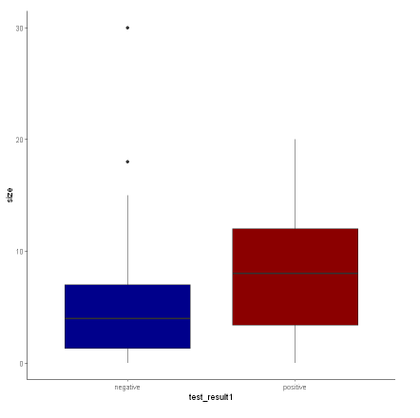
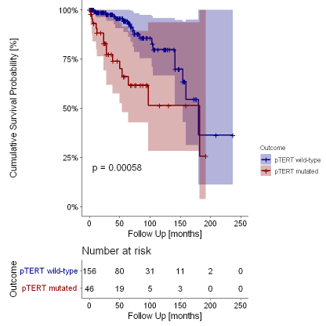
Figures
Fig.1: Survival curve demonstrating pTERT mutated (Red) vs pTERT wild-type (Blue) with cumulative endpoint of recurrence, metastasis, and death from disease.
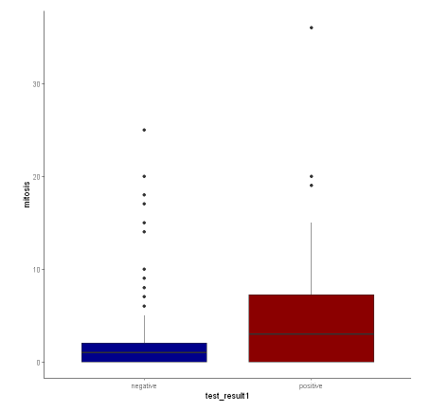
Fig.3: Boxplot showing mean mitotic count/10 high power fields of pTERT wild-type (negative) and pTERT mutated (positive).
p = 0.00028
p = 0.00026
Fig.2: Boxplot showing mean size of pTERT wild-type (negative) and pTERT mutated (positive).

