Public Engagement Scheme Award – 3D specimens

Introduction
The Pathsoc funding (Public engagement scheme grant - £2950), in conjunction with HEIF funding for the same project, was used to buy equipment to enable the production of 3D virtual reality pathology specimens. Conventional pathology specimens in jars are a valuable educational resource but are associated with problems such as specimen deterioration, leakage of hazardous fixative solutions, and problems with access to specimens. Many are unique and can only be viewed by a small number of people at once. In addition, for public engagement activities, real specimens may be considered too gruesome by some people. Due to the effects of modern pathology practice and the Human Tissue Act, it is extremely difficult to add new specimens to pathology museum collections. This project aimed to produce virtual reality pathology specimens that would be easily accessible, viewable on a computer and less gruesome than a specimen in a jar.
Production of specimens
Formalin fixed specimens from consented autopsies and surgical cases were photographed with a standard digital SLR camera and images imported into 3DSOM software for conversion into 3D digital objects which were output as flash or java animations. These are viewable in an internet browser.

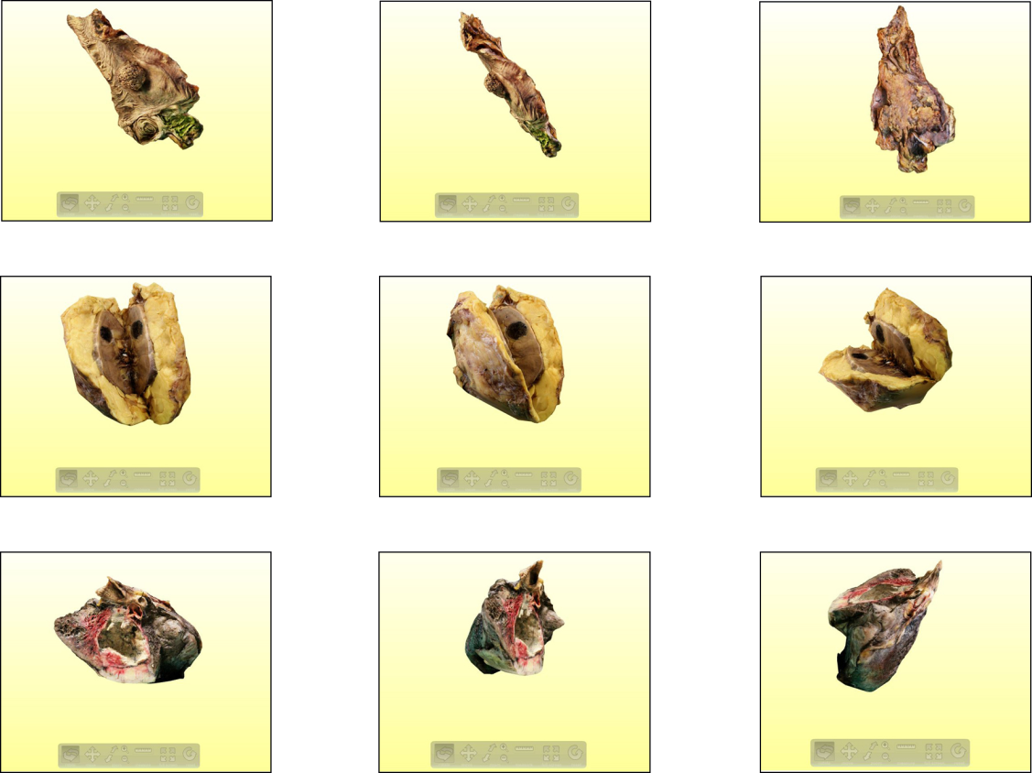
Still images from 3D organ sequences. Top row: right hemicolectomy with polyp. Middle row: kidney with tumour. Bottom row: lung with cavitating tumour.
Public engagement events
Two events using the specimens have been held so far:
Pathology department stand in St James’s University Hospital June 11-15th 2012.
The event in St James’s University Hospital took place in the main entrance of Bexley Wing (the oncology centre) and was attended by patients, relatives and hospital staff. The stand explained what happened to a pathology specimen in the department and why pathology was important for diagnosing and treating disease. Many people were interested in the 3D organs on display (right hemicolectomy with polyps, nephrectomy with renal cell carcinoma) and were surprised to learn that pathology specimens were processed within the hospital, and that a patient would still be alive after having a whole kidney removed. Using the specimens it was easy to demonstrate that the kidney tumour did not extend outside the kidney and explain the concept of specimen margins and why these were important. The event ran for around 2 hours each day over 5 days and attracted over 100 visitors.
The pathology department stand in Bexley wing, St James’s University Hospital.
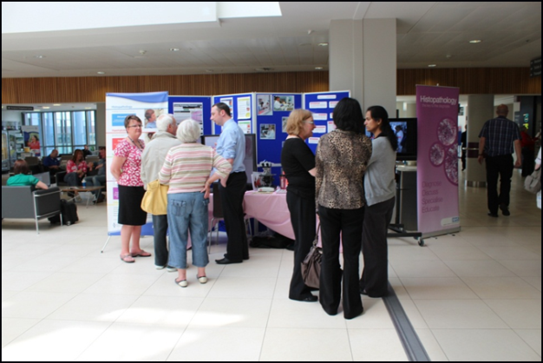

Disease Detectives event at the Thackray museum, Leeds Aug 6-10th 2012.
This event was organised in conjunction with the Thackray museum’s “Medical Innovators and Inventions” event. It included information on what happens to pathology specimens in the department and why this is important, images of specimens, histology slides and a digital microscope. The event was mainly attended by children’s groups, families, and some students. On the first day, there was a large group of children from a local Kids Club (aged between 4 and 12 years). Two Degree students from University of Leeds also attended on the first day and produced a video of (consented) interviews from the event organiser, children and minders of Kids Club group, as well as a couple whose experience related to their personal issues. This can be viewed (using Real Player) at http://www.leedstrinity.ac.uk/sites/cfj/features/Pages/MedicaMuseum06-08-2012.aspx
Approximately 325-350 people attended the event over the five days with the majority of visitors being impressed by the exhibits and the fact that they could interact with pathologists.

A 3D heart specimen was also demonstrated on 2 days during the “Dissect a heart” event for children and families at the Thackray Museum, Leeds from 18th to 22nd February 2013, which was attended by around 45 people per day.
Dissemination
Examples of 3D organs have been shown at the Pathsoc summer meeting in Sheffield (July 2012, oral presentation), the NCRI Cancer Conference in Liverpool (November 2012, poster presentation) and the Yorkshire and the Humber Deanery Academic Presentation Day (May 2013, poster presentation).
Future work
We will continue to photograph specimens to produce 3D models and have begun to MRI scan specimens as a complementary technique to produce virtual specimens which can be sliced to show the internal structures. Specimens will be used at future public engagement events.
Other uses for the specimens include the potential for clinicians to use them for patient education and for feedback to surgeons. The 3D specimens will be incorporated into teaching materials for pathology trainees and students and will be available on the Pathology ST1 educational website (in development) which is funded by the National Histopathology Training Schools Board.

