Public Engagement scheme from The Pathological Society
‘Womb for Improvement’ funding report
Our team of Leeds Pregnancy Researchers were delighted to receive funding from The Pathological Society for our public engagement event. The University of Leeds runs a public engagement event called BeCurious. This open access, free event showcases research taking place at the institution to members of the public. Due to the Covid19 pandemic, BeCurious in May 2022 was the first event since 2019. This is a competitive event, and we were successful in securing a station, which we called ‘Womb for Improvement’. Our first aim was to showcase our research into extracellular vesicles, and the molecular regulation of placental vascular function, using interactive methods. We also wanted to use the opportunity to deliver public health messages about the impact of health in pregnancy and a childhood on longer term adult health. We also hoped to raise the profile of our research both within the University and local community.
BeCurious took place on Saturday 7th May from 10am-4pm, with a footfall of over 1,200 people. The target demographic was families, with the aim of getting young people interested in research and to introduce the concepts of the developmental origins of adult disease at an early stage. The funding from The Pathological Society enabled us to design our activities and purchase equipment and materials. As such, running our event would not have been possible without the £1,400 we received. Our main activities were as follows:
‘PlacentArt’ placenta printing
PhD student Abigail Byford designed and made templates depicting placental structure at stages of development. On the day, participants could use these templates with paint, printing materials and card to make their own placenta images to take home with them. This was a very popular activity with older children.
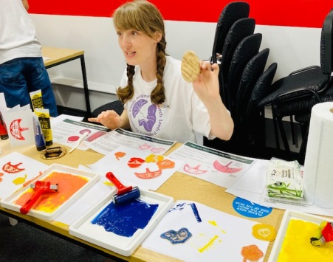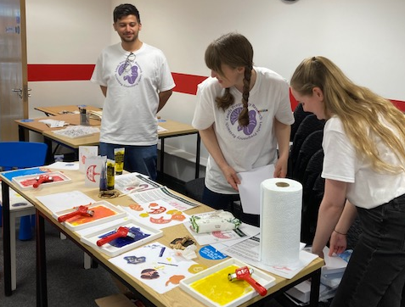
‘Building a Healthy Future’ game
I designed this activity and commissioned its production by Duke Makes studios in Leeds. The interlocking and stacking blocks represent how good foundations of health lead to an increased likelihood of healthy adult life. This included preconception care for the mother, good antenatal care and placental function and healthy childhood. Children were able to link the corresponding blocks together, matching by either number, image or the words, then stack them into a tower. Children enjoyed doing the activity, but this also prompted lots of discussions with adults about health over the life course. We will be able to use this game at events in the future.
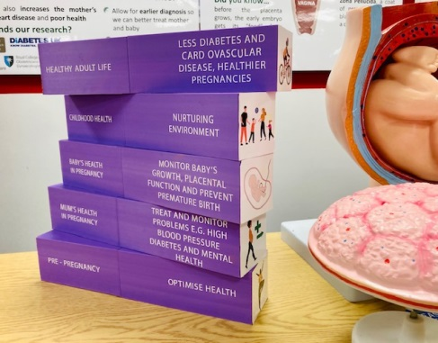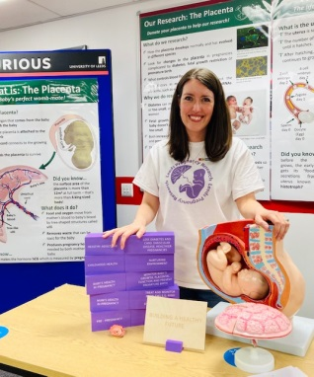
Extracellular vesicle demonstration
We wanted to demonstrate that extracellular vesicles are packages that transport important information e.g., DNA, proteins, lipids between cells. These cells can be in different organs and even enable communication between maternal and fetal circulations. We displayed a transparent balloon with inner balloons showing the cargo within the vesicles. We used red water beads to mimic maternal blood, with coloured beads within a bowl that represented extracellular vesicles travelling to different organ systems. Participants were invited to find the coloured beads with the ‘mum’s blood’ and match them to the correct organ. This was a very popular activity with younger children as the beads were very tactile.
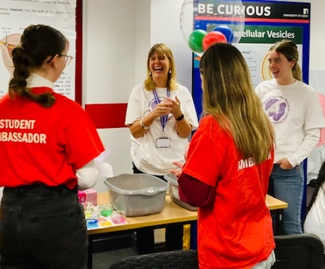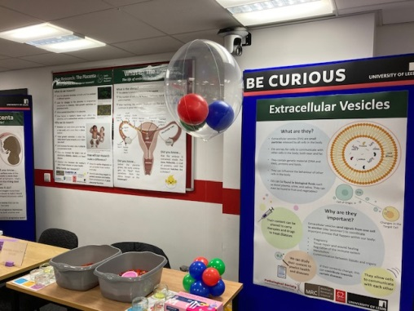
We also showed posters explaining our research in more detail for further discussion. We had a raffle draw, where prizes were custom tote bags and notebooks featuring our Leeds Pregnancy Research logo. We also had a question-and-answer quiz in ‘eggs’ about reproduction. A station where people could leave feedback and receive stickers was also available, and we had T-shirts printed with our logo for those helping on the day.
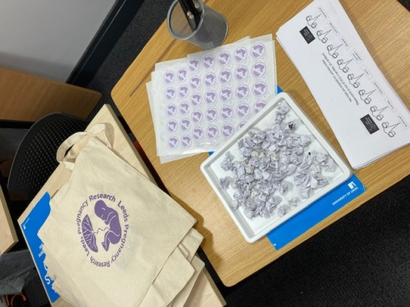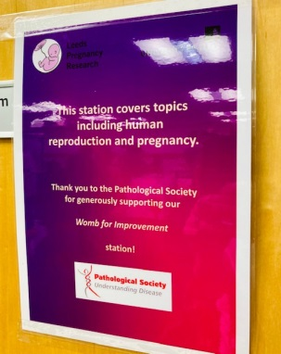
We collected feedback from attendees on our predesigned proformas, which was entirely positive. Once again, we would like to say thank you for supporting Leeds Pregnancy Research with your Public Engagement scheme.

