MADEX 2019 REPORT

Madagascar Medical Expeditions

“Bilharzia vitan'anamalaho ve dia hamonoana vatotr'akoho”
-----------------------------------------
“Bilharzia can be prevented so should be prevented”

I would like to begin by thanking the Pathology Society for their incredibly kind donation of £675 towards my medical elective in Madagascar.

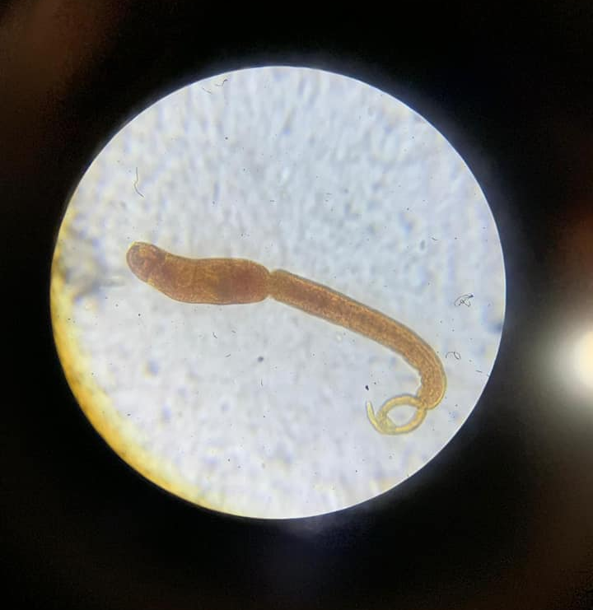
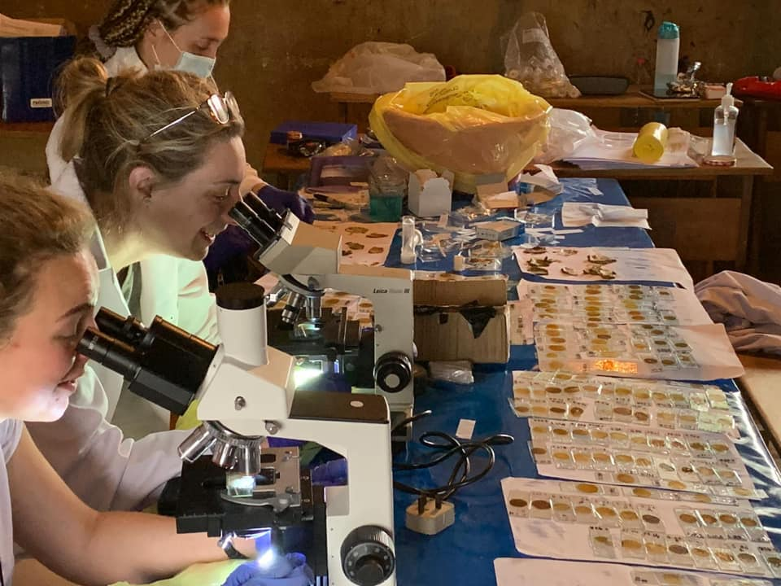
This money I received was donated to Madagascar Medical Expeditions (Madex); the medical research team I went to Madagascar with. This money contributed towards the flight which allowed us to get to the remote region of Madagascar where we undertook our research. Without this 40 minute internal flight we would have had to spend 4 days travelling on incredibly bumpy and unsafe roads to the village. Additionally, this allowed us to spend extra time undertaking our research. This money was therefore greatly appreciated by both myself and the student led expedition team. I have attached some photos from my expedition to reflect my time spent in Madagascar.
Brevifurcate-apharyngeate distome cercariae found at one of the sites
The 7 seater plane we travelled from the capital to Marolambo in
The team analysing the stool samples under the microscopes
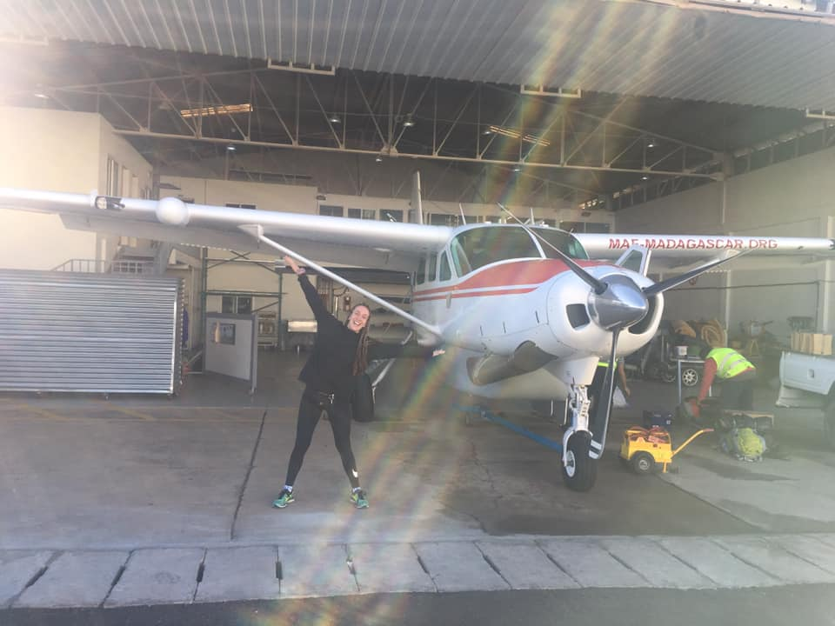
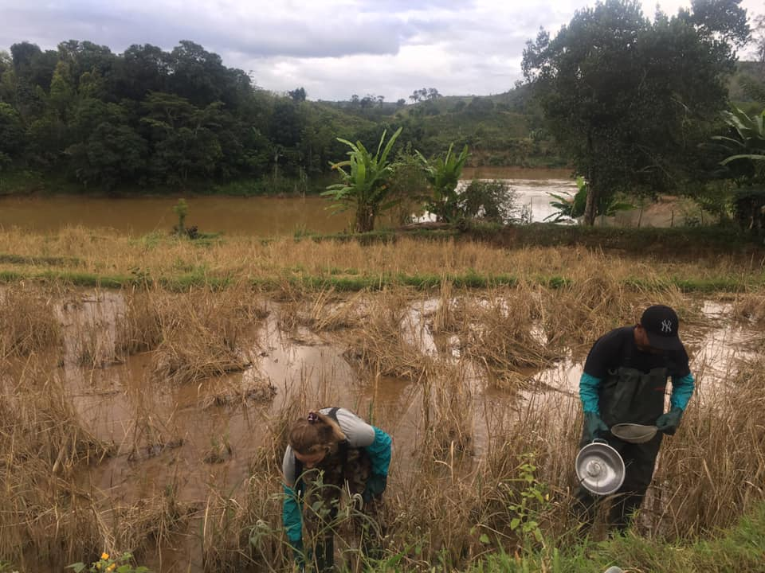
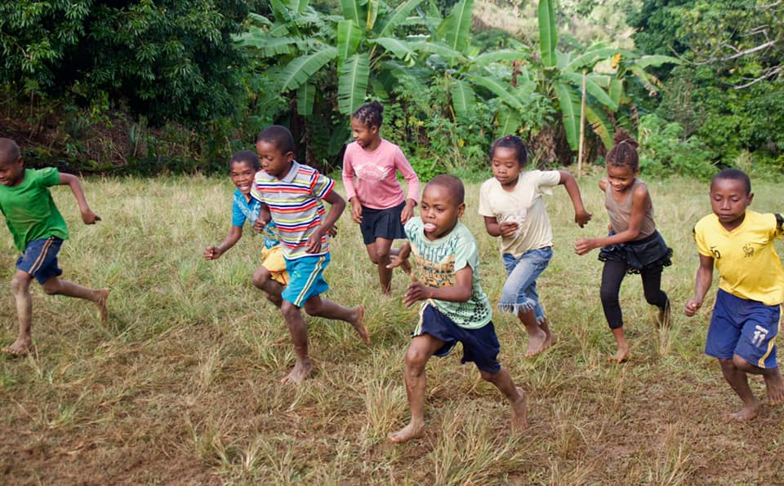

Looking for the snails in the local water sources
Some participants taking part in the bleep test as part of the morbidity assessment.

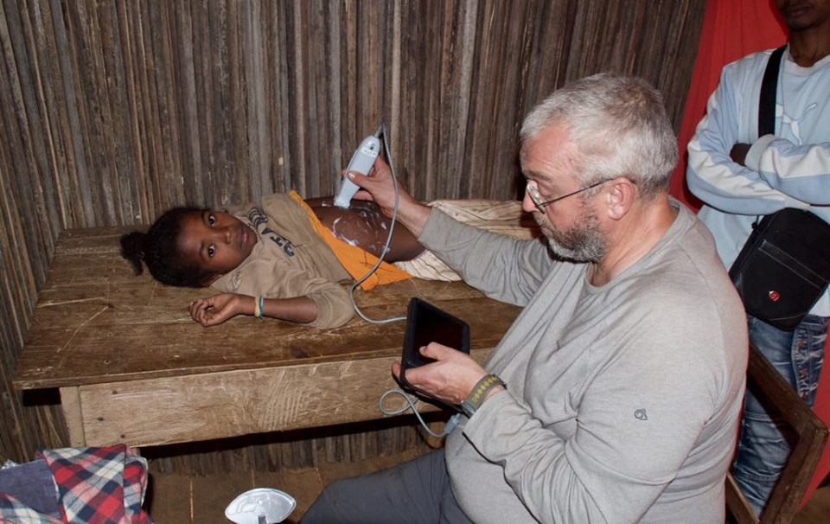
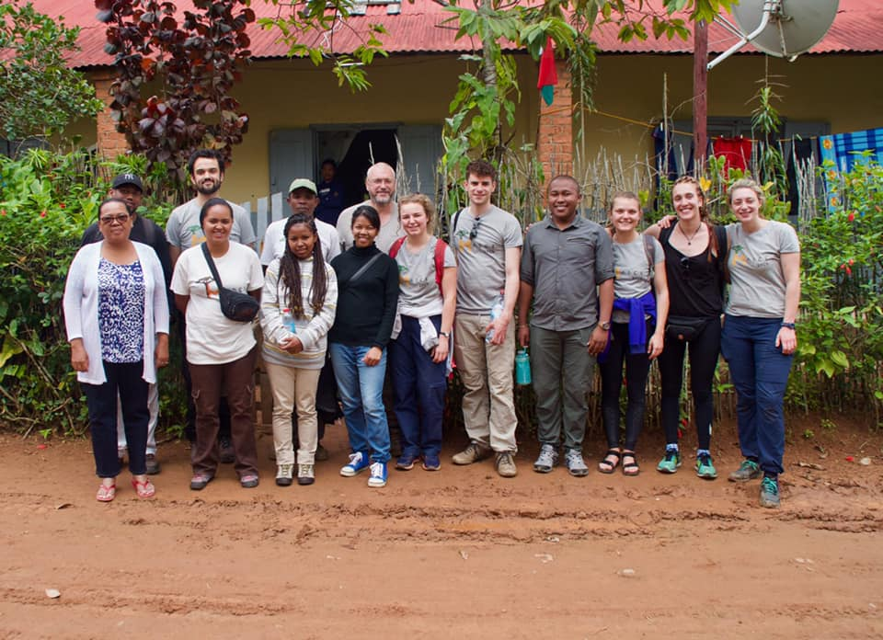

The Madex 2019 team
Graham, consultant radiologist ultra-sounding a child
Introduction:
Schistosomiasis is a parasitic disease caused by contact with contaminated water and associated with significant morbidity and mortality. I spent my elective working with Madagascar Medical Expeditions (MadEx) to reduce the burden of schistosomiasis in the Marolambo District of Madagascar. Madex is a student led programme which has been running annual expeditions to Madagascar since 2015. Each year the team investigates the prevalence and morbidity of Schistosomiasis and Soil Transmitted Helminths amongst school aged children in a remote region of Madagascar; Marolambo. This year the team was comprised of 13 members; 7 English students/doctors and 6 Malagasy medical students/doctors.

The expedition built on a programme established in 2015 by MadEx. We visited 6 villages along the Nosivolo river in Marolambo, all of which were found to have extremely high prevalence of schistosomiasis in 2015. Six villages were included in the full study; the same six which had been studied by MadEx since 2015. Within each village we carried out our research as well as performed mass drug administrations and ran education programmes for local children.

This year marked the start of a five-year longitudinal study.

Aims for the 2019 expedition:
- To commence a five year longitudinal study to assess the prevalence and morbidity of schistosomiasis in school-aged children
- To treat the children in the district alongside the Ministry of Health with mass drug administrations of Praziquantel
- To deliver an education programme to children in the district and carry out pre and post education questionnaires
- To research the distribution and patterns of biomphalaria snails in the villages along the Nosivolo river
- To research the prevalence of schistosomiasis in pre-school aged children (2-4 year olds)
- To develop a novel ultrasound technique to compare the assessments of novices with an expert in assessing for liver fibrosis associated with S. Mansoni.

Results
- Disease Prevalence:
Urine samples of 365 children were tested using CCA analysis. We found 86% of the urine tests to be positive for schistosomiasis. We also used Kato Katz technique to analyse the stool samples for infection intensity. 204 out of 345 children (59%) were Kato Katz positive. The mean eggs-per-gram (EPG) for all of the children tested, indicating mean infection intensity was 127.23 epg (moderate infection intensity). Of the children who tested positively on Kato Katz, 115 had light infection intensity, 55 had moderate infection intensity and 34 had heavy infection intensity (Table 1).

Kato Katz |  | Total |  | Female |  | Male |  | Age (years)
 |  | Total | % of all partic. | Total | % of all partic. | Total | % of all partic. | 5-6 | 7-8 | 9-10 | 11-12 | 13-14
 | Negative | 141 | 41% | 74 | 22% | 67 | 19% | 30 | 38 | 23 | 29 | 21
 | Light | 115 | 33% | 62 | 18% | 53 | 15% | 31 | 20 | 19 | 22 | 23
 | Moderate | 55 | 16% | 22 | 6% | 33 | 10% | 7 | 6 | 16 | 14 | 12
 | Heavy | 34 | 10% | 19 | 6% | 15 | 4% | 5 | 4 | 8 | 10 | 7
Table 1: The infection intensity of schistosomiasis (negative, light, moderate, heavy), determined by ‘eggs per gram’ of faecal matter as per the Kato Katz method of 345 children. Levels are shown for female and male children across five age brackets.

Soil Transmitted Helminths:
Alongside looking for schistosomiasis, we also estimated the numbers of soil transmitted helminths (STHs) in the stool samples. The overall prevalence of STHs across the 394 children was 89%.

Disease morbidity
Anaemia:
66% of the 338 children tested for anaemia were found to be anaemic according to WHO Haemoglobin concentrations for the diagnosis of anaemia and assessment of severity standards.

Our results for organomegaly, anthropometric data and cardiovascular fitness levels as measures of disease related morbidity are still under analysis.

- Mass Drug Administration
Before leaving each village the MDA was carried out. The Praziquantel was supplied by the Ministry of Health in Madagascar for the expedition but unfortunately there were issues with supply of Mebendazole so the children were not treated for soil-transmitted helminths. This year 80% of children involved in the study attended the MDA.

- Education Programme:
The impact of the MADEX education programme was assessed by comparing the results from the knowledge, attitudes,and practice (KAP) questionnaire answers before and after the education was delivered. An improvement was found in the children’s understanding of schistosomiasis. As shown in Figure 1, When asked about the course of schistosomiasis infection, the average proportion of children demonstrating knowledge that the infection lasts “until treated” changed from 32% to 94%.

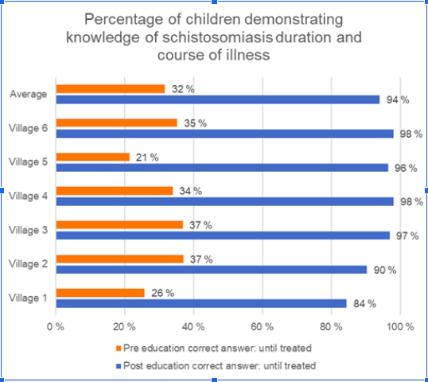

Figure 1: Percentages of 389 children who answered “until treated”, correctly identifying the duration and course of schistosomiasis, when asked about the longevity of the disease. pre-education versus post-education.

An improvement was also found in the understanding of prevention and mode of transmission of schistosomiasis. The average proportion of children demonstrating knowledge that the infection is contracted by contact with infested water rose from 75% to 93% with our education programme. With regards to treatment, the average proportion of children across the six villages who recognised praziquantel as the treatment rose from 52% to 92%.

- Distribution and patterns of biomphalaria snails
A total of 117 Biomphalaria were collected across the 33 sites. 41% of the freshwater positive snail sites were positive for Biomphalaria, in which five of the six villages sample contained at least one positive site for Biomphalaria snails. Of the three water contact themes surveyed, only streams and rice paddies were found to be positive for Biomphalaria.

- Research prevalence of Schistosomiasis in pre-school aged children
89 children aged between 2 and 4 years were recruited into the pilot study to determine the prevalence of s. mansoni in this age group. We aimed to obtain a urine and stool sample from each of these children. 80 children subsequently provided a stool sample and 86 provided urine samples. The total prevelacne of schostosomiaisis amongst these children was 66% and of these just 1% showed a heavy infection intensity.

- Ultrasound:
Power was the biggest challenge of the ultrasound research. The capital village in the Marolambo District has a large generator and a couple of the buildings have AC power sockets. Here we were able to maintain sufficient charge to power both the i-Viz and Edge simultaneously. However, the 5 villages upstream did not have any power at all.
We had accounted for this prior to leaving for Madagascar by recruiting the help of a solar panel expert. With his help, we felt ready to gather and store enough solar energy to power the two ultrasound devices. This would be done with battery packs, car batteries, solar panels, power inverters etc.

The two power inverters’ fuses blew when attached to a car battery, and then the transformers within the i-Viz and Edge were damaged by a power surge from a generator.

The medical students scanned 320 children, the radiologist scanned 293 children (164 with the i-Viz, 129 with the Edge). Of the students’ 320 scans, interpretation by the student operator estimated 242 (75.6%) as ‘normal’, 74 (23.1%) as ‘mild-moderate fibrosis’ and 3 (0.9%) as ‘severe fibrosis’.Preliminary findings suggest that the majority of the children included have at least very early fibrotic liver changes. With the clips obtained from the scanning, we will be comparing the findings of the ‘expert’ and ‘novice’ scanners to see whether our much simpler protocol could be used in the future to test populations for schistosomiasis-related liver fibrosis.

Conclusion and future work

This research expedition marked the start of a five-year longitudinal study to investigate schistosomiasis morbidity and deliver annual MDT in school-aged children. Six villages were included in the full study; the same six which had been studied by MadEx since 2015. Following the study, MDA and education programmes were delivered to the villages.
Teachers were trained to deliver education to ensure longevity of community-led efforts against schistosomiasis.

Biomphalaria snails were found in various water sites but particularly in streams and rice paddies. The peak time in the day for parasites to be shed from snails was between 9am and 11am. These findings are vital for informing future education programmes on lower-risk water contact time.

High schistosomiasis prevalence amongst preschool-aged children appears to reflect significant exposure to the parasite from a very young age. This is consistent with other recent studies and aligns with the argument for increasing the age range of MDA treatment to include preschool-aged children.

There appears to be considerable morbidity associated with such a heavy infection burden in this region. Preliminary findings suggest that the majority of children have at least early stages of hepatic fibrosis. The majority of children (77%) also had a degree of anaemia. There are likely to be a number of factors contributing to rates of anaemia such as high prevalence of soil-transmitted helminths, and a 39% prevalence of malaria.

The team stayed well and in good spirits during the trip. Relations with the community remained very good. We had a strong sense from the communities that they would like us to continue our work and expand to include more villages and to include more diseases in our studies if possible. We presented our findings to the community, the Faculty of Medicine in Antananarivo and representative from the Ministry of Health in Madagascar.

Since implementation of MDA and education programmes annually since 2015, we have seen a reduction in overall prevalence and mean infection intensity. Over the next 4 years, we will continue to monitor the impact of health interventions on, not only infection status, but also morbidity.

The team will spend the next year analysing and writing up the data in the form of articles for submission to journals and to deliver presentations as well as making plans for the research expedition in 2020.

Once again, many thanks to the Pathology Society for their kind donation which has enabled our expedition to go ahead.

Heather Lawson
University of Sheffield.

