Pathological Society Bursary Report
Midland CELLibration 2012, a biennial event organised by the Central Cellular Pathological Society (CCPS), was held at the Hinckley Island Hotel 26th-28th October. The conference was a huge success with attendance of 168 delegates over the weekend and support from numerous Trade representatives.
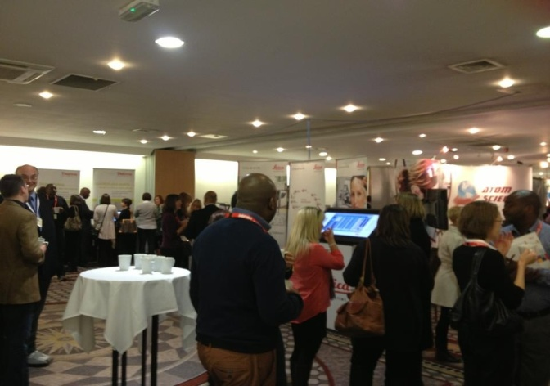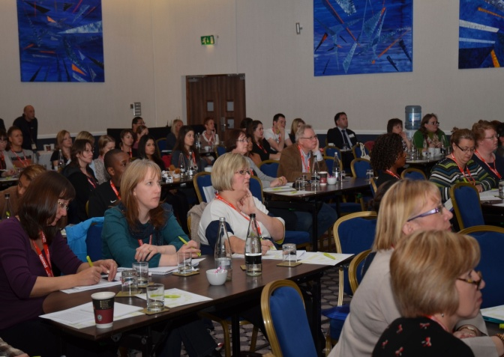
It was the first time the committee had organised a poster presentation and these were submitted under three categories: Basic Histology, Basic Cytology and Recent Advances in Cellular Pathology. Submissions were accepted from Trainee Biomedical Scientists to doctors, emphasising the range of educational backgrounds. This new addition to the Midland CELLibration programme was facilitated by the bursary received from The Pathological Society, which funded the day delegate rate for the presenters and also the winners’ prizes. The success of this has set precedent for future years.
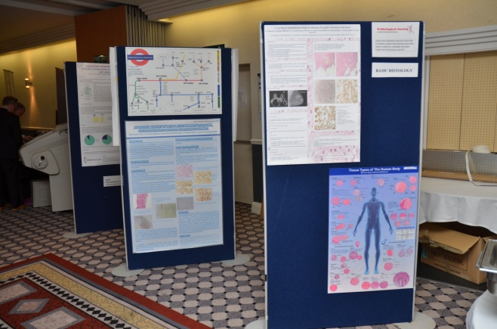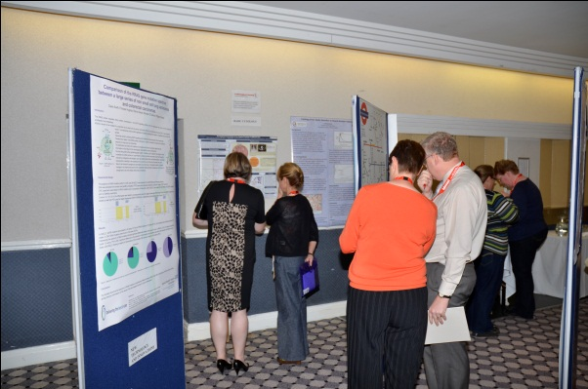
The educational programme was thoroughly diverse with subjects ranging from “Immunohistochemistry in Breast Cancer Diagnosis” and “Aspirin, Inflammation, DNA Repair and Colorectal Cancer” to “Mummies from Around the World” and “Death Masks”.
One of the truly inspiring talks was delivered by Jill Rodney, the Chief Executive of the IBMS, who spoke about “Meeting the Changing Needs of the Profession”. Following her presentation, Jill presented the prizes for the winning categories in the poster presentations.
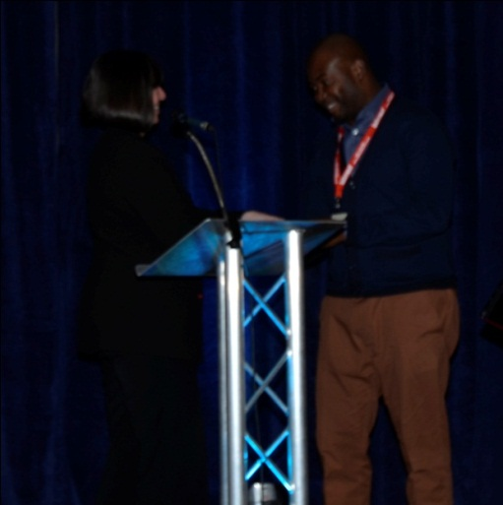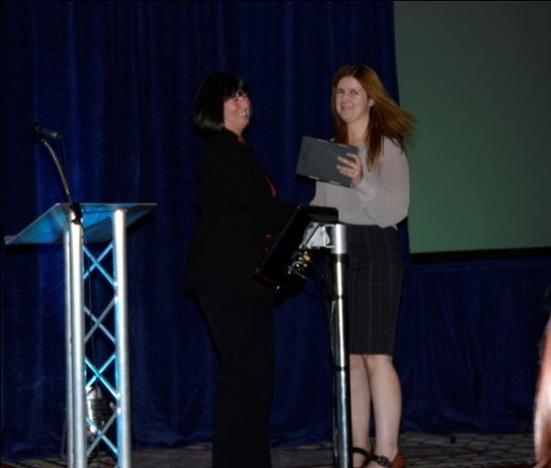
The weekend included an evening meal with a “Gangsters and Molls” theme which gave delegates an opportunity to meet colleagues from other hospitals from around the country.
The CCPS Committee’s thanks go to the Pathological Society as their funding enabled certain delegates to attend who may not otherwise have received financial support, and enabled Continued Professional Development for all involved.
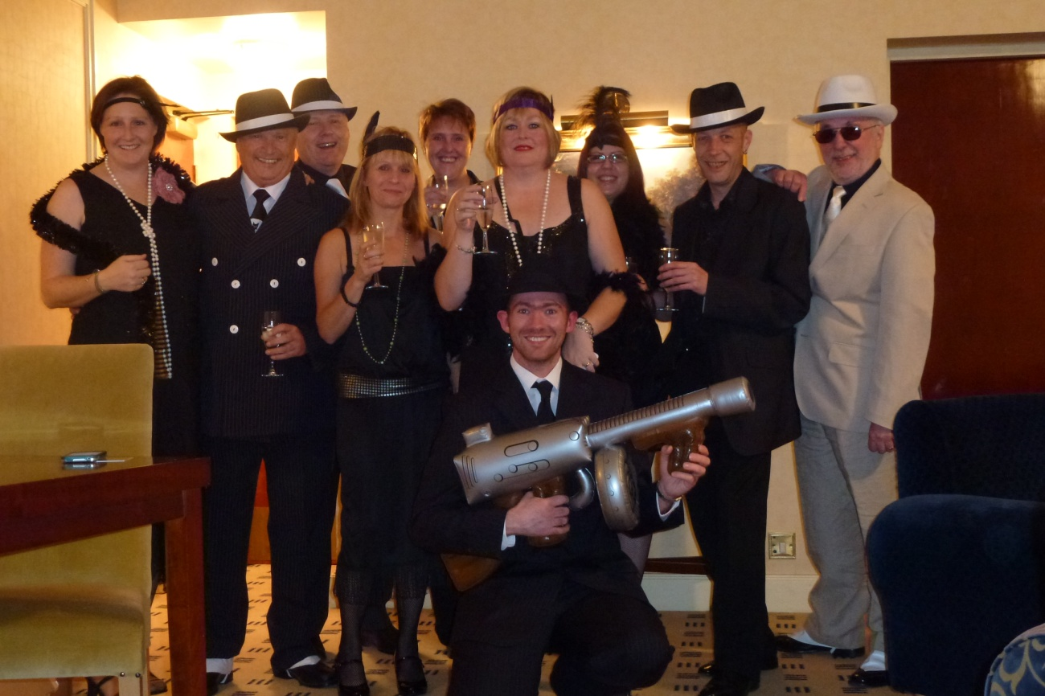
We look forward to Midland CELLibration 2014 and hope to see some new faces there!

