Clinicopathological Relationships in Motor Neuron Disease- Pathological Society Report
Introduction
Motor Neuron Disease (MND) is a neurodegenerative disorder causing progressive muscle weakness, with a mean age of onset of 55-60 years old. The mean survival is 3-5 years from symptom onset, with the cause of death usually being respiratory failure (Worms, 2001).
Aggregates of hyperphosphorylated full length transactive response DNA-binding protein of 43kda (TDP-43) and cleavage products of the C-terminals of this protein have been found in the cytoplasm of diseased motor neurons, and are now considered the pathological hallmark of MND (Arai et al., 2006; Neumann et al., 2006). Normally, TDP-43 is largely confined to the nucleus, raising two possibilities for its role in MND pathogenesis: a loss of nuclear functional TDP-43 or a toxic gain of cytoplasmic functional TDP-43, or both (Mori et al., 2008). However, the exact mechanism and the reason for the selective vulnerability of neurons is still unknown.
In MND, TDP-43 pathology tends to appear in the brain in a staged manner, described by the Brettschneider system (Brettschneider et al., 2013; Figures 1 and 2). Neuropathological staging systems are useful to aid our understanding of the pathology behind diseases, and if they correlate to clinical features, they may have prognostic value for patients. Previous work staging neuropathology in Alzheimer’s disease (AD) and Parkinson’s disease (PD) has paved the way for similar work in MND (Braak et al., 2003, 2006). All the existing neuropathological staging systems have imperfect correlations to clinical features of disease. The Brettschneider system only appears to correlate to cognitive impairment in later disease stages, and the development of pathology in some of the regions affected does not appear to relate to the clinical features of disease, for example MND patients do not show symptoms suggestive of basal ganglia disease.
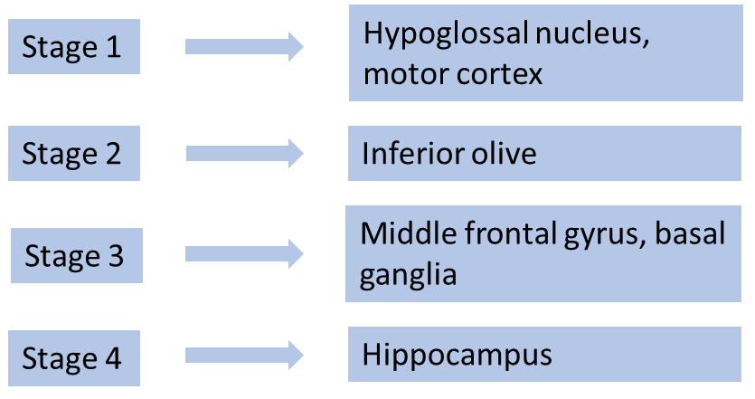
Figure 1- The Brettschneider staging system. Inclusions also occur in the spinal cord in stage 1, and in the reticular formation and other precerebellar nuclei in stage 2, but these regions are not considered essential regions for staging and thus are not included in the diagram.
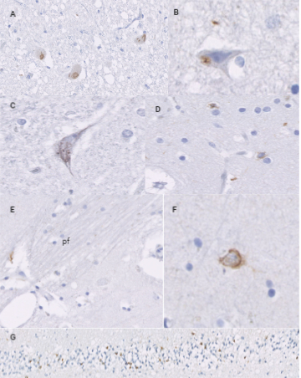
Figure 2- pTDP-43 Immunohistochemistry Demonstrating Brettschneider Staging. pTDP-43 (phospho-TDP-43) immunohistochemistry showing examples of pathology for each stage of the Brettschneider system. Stage 1= A, B. A: Neuronal cytoplasmic inclusions (NCI) in hypoglossal nucleus. B: NCI in motor cortex. Stage 2= C. C: NCI in inferior olive of medulla oblongata. Stage 3= D, E, F. D: Neurite next to pencil fibres (pf) in striatum of the basal ganglia. E: Oligodendrocyte inclusions in striatum. F: Glial inclusions in middle frontal gyrus, which has been sampled here in place of gyrus rectus/orbitofrontal gyrus. Stage 4=G. G: Inclusions in dentate gyrus of hippocampus proper.

We wanted to further investigate the staging of TDP-43 pathology in MND and see if this correlates to clinical information, which will help us to determine if the Brettschneider system may be a useful tool for research and clinical practice. Therefore, the following aims were established:
• To determine if the order of regions in the Brettschneider et al. (2013) staging system is an accurate reflection of progression of pathology.
• To determine if there is a correlation between pathological staging of MND and clinical progression.
From these aims, we derived the following hypotheses:
• The pathology progresses in the order laid down by Brettschneider et al. (2013).
• More rapid disease progression and higher stages of disease, including the development of cognitive and psychiatric symptoms, will be associated with higher Brettschneider stages.

Methods
This project was performed in collaboration with the Sheffield Brain Tissue Bank (SBTB), which holds ethical approval to operate from the Scotland A Research Ethics Committee (REC reference 19/SS/0029; IRAS project ID 261271). This includes ethical approval to retrieve clinical information from patient notes. Tissue was supplied with permission from the SBTB management board request number 18/007.
Clinical data was obtained from the notes of 37 patients, and added to the existing data in the SBTB, for a total of 217 patients with clinical data. Of these, 34 were selected for use in the study, based on availability of brain tissue and completeness of clinical data.
We constructed TMAs of 3 regions of 33 MND cases in the SBTB, these being striatum, motor cortex and middle frontal gyrus. Medulla (hypoglossal nucleus and inferior olive) and hippocampus (hippocampal formation) were assessed using regular sections as opposed to TMAs due to the intricate nature of the structures, small size and high value of these regions meaning TMAs are unsuitable. The final case was not included in the TMA as it was added to the study later.
A TMA is a paraffin block in which multiple tissue cores are inserted in array fashion. A ‘recipient block’ is a paraffin block that tissue cores are inserted into, and a ‘donor block’ is a tissue block that a core is taken from to be placed in the TMA (Figure 3). We wanted to use TMAs in order to be able to easily compare cases and reduce the amount of time and materials we needed to use.
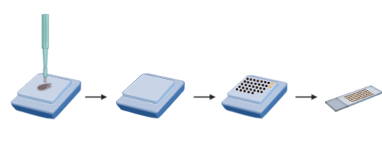
Figure 3- TMA Construction. Cores from the ‘donor’ blocks are punched and inserted into holes in the paraffin ‘recipient’ block. The process is repeated until the recipient block is full, which is the annealed and can be sectioned.

All TMAs were constructed using the Beecher MTA-1 Tissue Microarrayer (Figure 4). We used a 2mm diameter core of tissue with spacing of 3mm between cores to prevent fracturing of the recipient block. A 2.5mm perimeter was established around the outside of the recipient paraffin blocks to prevent fracturing. To ensure sections of the finished block could be reliably orientated to identify the source of each core, we used 2 methods to ensure that the blocks did not have rotational symmetry: Firstly, 2 cores of FFPE chicken breast were added to the end of the top 2 rows as this is easily distinguishable from brain tissue, and secondly the final row has fewer cores such that the array of cores did not have rotational symmetry (see Figure 5). This allows 33 cores of human tissue to fit on to each TMA.
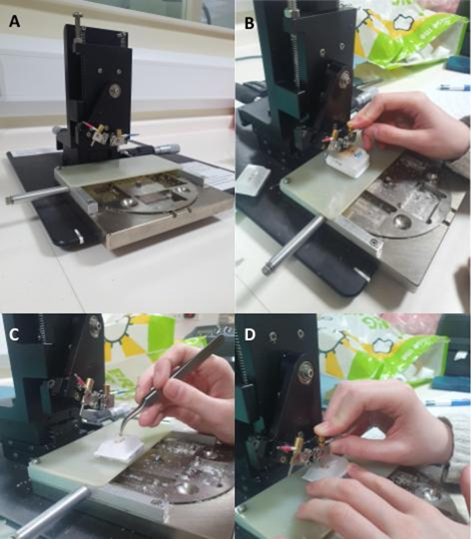
Figure 4- Photographs of Beecher MTA-1 Tissue Microarrayer. A- Image of the Beecher MTA-1 Tissue Microarrayer before use. B- Punching of a donor block. C- Insertion of a core into a punched recipient block using tweezers, which allows for any extra wax on the core to be trimmed off with a scalpel before inserting into the TMA. D- Insertion of a core into a punched recipient block straight from the machine punch, which is easier than using tweezers but means wax may be inserted into TMA with the core.

Figure 5- Configuration of a TMA. 33 cores of tissue (brown circles) are arranged in the configuration as shown with 2 cores of chicken breast (yellow circles) as shown in order to facilitate orientation of slides cut from the TMA block. A shows a diagrammatic representation of this format, and B shows a photograph of one of our finished and sectioned TMAs with this format.

Finished TMAs were annealed in an incubator at 37℃ face-down on a glass microscope slide. Once annealed, TMAs were left to cool overnight before sectioning at a width of 5μm and incubating overnight at 37℃.
Slides were dewaxed in xylene for 2x5 minutes and then rehydrated through graded alcohols at 100%, 100%, 95% and 70% for 5 minutes each. Endogenous peroxidase activity was blocked by incubating in 3% hydrogen peroxide in methanol for 20 minutes. Slides were then washed in tap water before antigen retrieval using ‘access revelation’ solution the antigen access unit. Slides were stained with anti-phospho-TDP-43 antibody using an autostainer. A positive and negative control was used with each run. Stained slides were dehydrated back up through the alcohols and then transferred to xylene before coverslipping with DPX and then incubated overnight at 37℃.
Immunostained slides were scanned on to an external hard-drive using the Hamamatsu slide scanner. Images were viewed using the NDP view 2 imaging software and analysed for presence or absence of TDP-43 inclusions, including neuronal, glial and/or neuritic inclusions. For a case to be judged as being positive for TDP-43 pathology, there needed to be at least two inclusions of any type. All pathological data was checked by a qualified neuropathologist (Dr Robin Highley).
All statistical analysis was done using SPSS version 25, with α set at 0.05. Relationships between stage and age of onset assessed using a Kruskall-Wallis test when using Brettschneider stage. Fisher's exact test was used to compare stage and cognitive and psychiatric involvement. A log rank test was used to compare pathological stage and survival duration.

Results
Due to extensive core loss on the TMAs, we were unable to use motor cortex or middle frontal gyrus tissue to stage cases. Therefore, the staging system we have applied is a modified version of the Brettschneider system, and results may not be an accurate representation of what may have been found if we had been able to use the full staging system. Core loss has also meant that for some of our analysis, there were fewer cases analysed for motor cortex and middle frontal gyrus than the other regions. The low sample size may have introduced bias into our results here. However, the use of TMAs in neuropathology has been established by previous work by this group (Wilson et al., submitted), and therefore, a TMA is capable of detecting TDP-43 pathology if it is there in the whole section. Under normal circumstances we would have re-stained the TMAs and used more cases. However, due to the COVID-19 pandemic, access to the brain bank and laboratory was lost and this could not be done.
We first attempted to determine whether the order of progression laid out by the Brettschneider staging system was correct. To this end, we calculated the percentages of positive cases per region (Table 1), with the expectation that 100% of the motor cortex and hypoglossal nucleus tissue would be positive, and that the percentage of positive cases in each successive stage’s regions would decrease in order. All 34 cases were included in this analysis, where tissue was available. These percentages did not reflect the expected pattern, as hypoglossal nucleus and motor cortex were both less than 100%, and the percentages did not decrease in a stepwise pattern by stage as the hippocampus percentage was higher than both the basal ganglia and the middle frontal gyrus percentages.

Region | Percentage Positive
Hypoglossal Nucleus | 88.9 (n=16/18)
Motor Cortex | 77.8 (n=14/18)
Inferior Olive | 52.2 (n=12/23)
Basal Ganglia | 23.1 (n=6/26)
Middle Frontal Gyrus | 18.8 (n=3/16)
Hippocampus | 27.6 (n=8/29)
Table 1- Percentage of positive cases per assessed region of the Brettschneider staging system.

We next staged our cases according to the Brettschneider scheme. Due to the extent of tissue loss on the motor cortex and middle frontal gyrus TMAs meaning we were unable to match tissue to cases, these areas unfortunately had to be excluded from our staging protocol. This meant that stage 1 was assessed on hypoglossal nucleus only, as opposed to hypoglossal nucleus and motor cortex, and stage 3 was assessed on basal ganglia only, as opposed to basal ganglia and middle frontal gyrus, with stage 2 and 4 assessed on inferior olive and hippocampus respectively, in accordance with the Brettschneider system (Brettschneider et al., 2013). Of the 34 patients in the study, only 12 had tissue from all these four regions, and therefore these 12 cases were the only cases fully staged according to Brettschneider. Of these 12 cases, 3 cases (25%) did not fit the pattern defined by the Brettschneider system, with stage 2 violating the system in all 3 cases, meaning that there was no pathology in the inferior olive but there was pathology in theoretically higher stage regions. Stage 3 (basal ganglia) violated the system in 1 case.
There was no relationship between Brettschneider stage and age of onset (Kruskall-Wallis=4.575, p=0.228; Figure 6).
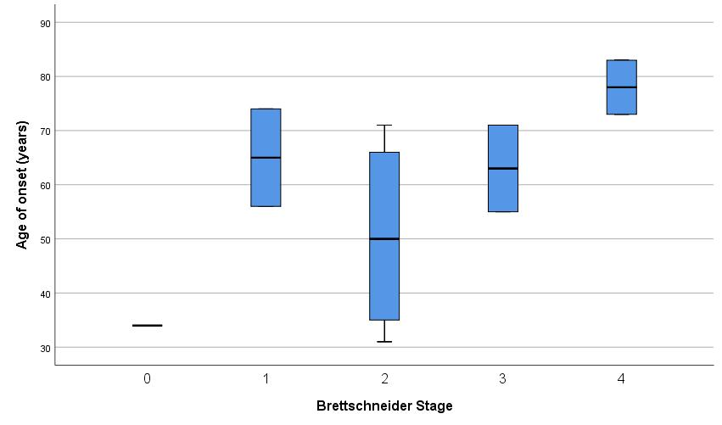
Figure 6- Boxplot showing relationship between Brettschneider stage and age of onset.

We found that Brettschneider stage has no impact on survival duration (log-rank χ2=3.189, p=0.527; Figure 7).
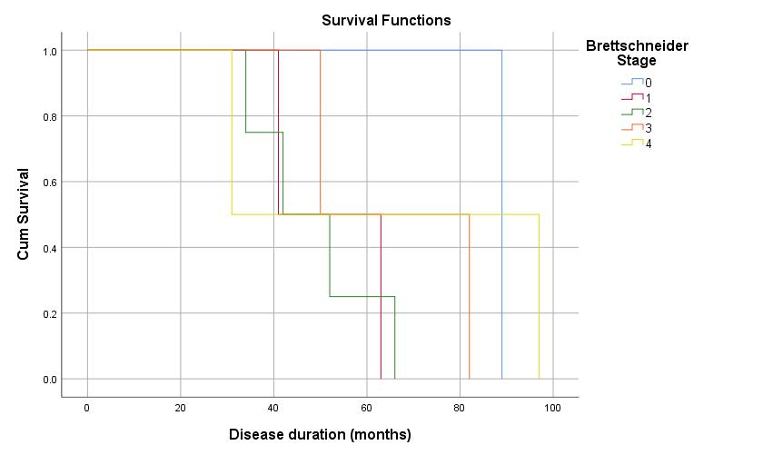
Figure 7- Kaplan Meier survival curve showing relationship between Brettschneider stage and survival duration.

The relationship between Brettschneider stage and cognitive impairment was not significant (Fisher’s exact χ2=4.963, p=0.636; Figure 8).
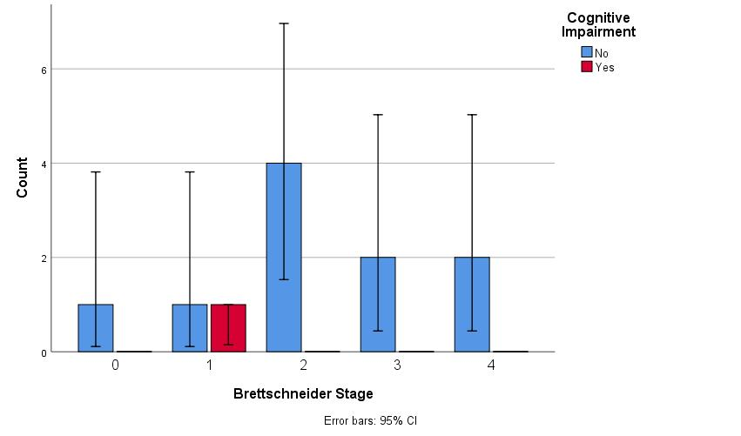
Figure 8- Bar chart showing relationship between Brettschneider stage and cognitive impairment.

There was no significant relationship between Brettschneider stage and psychiatric/behavioural symptoms (Fisher’s exact χ2=3.488, p=0.685; Figure 9).
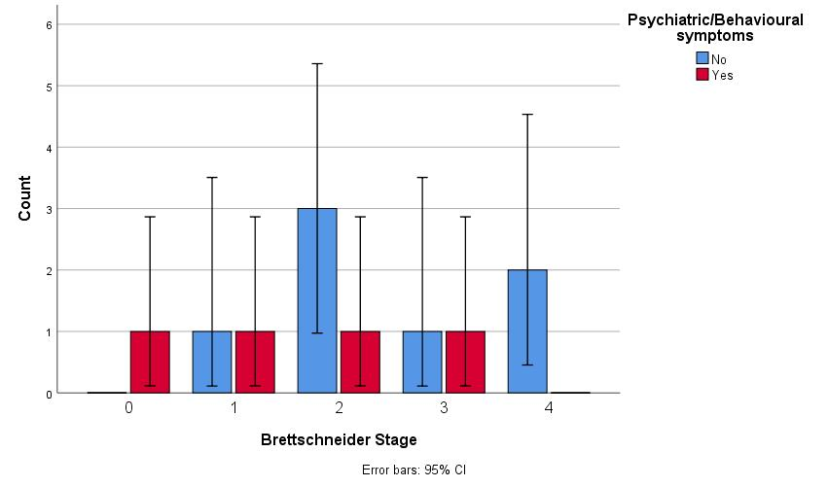
Figure 9- Bar chart showing relationship between Brettschneider stage and psychiatric/behavioural symptoms.

Discussion and Conclusions
Our results found that there was a significant proportion of cases that did not fit the Brettschneider system and that the overall pattern of the system (the percentage of cases positive per region) did not follow order given by the system. There were also no correlations to any clinical features. These results differ from findings of other studies, which suggest that there may be some clinicopathological correlations and that the general pattern of the system is largely upheld across different cohorts (Geser et al., 2008; Fatima et al., 2015; Tan et al., 2015). There is one study that supports our findings and suggests instead that staging systems should include regional pathological burden in addition to regions involved (Cykowski et al., 2017).
Our study is limited by a small sample size and the loss of pathological data from some of the TMA sections which was unable to be rectified due to COVID-19. We had initially also aimed to assess a wider variety of brain regions to determine if there was a better set of regions to use to stage, however we were unable to do this due to COVID-19.
In conclusion, the results of this study currently do not support the use of the Brettschneider system. Future work may involve investigating whether other pathological markers, burden of pathology, type of inclusion or synapses could be used for better staging. There has been research into the use of imaging techniques to translate pathological staging systems into radiological format, although so far this has not been successful (Kassubek et al., 2018). If a more accurate pathological staging system and a way to translate this into imaging could be developed, this would be a useful prognostic tool.
References
Arai, T., Hasegawa, M., Akiyama, H., Ikeda, K., Nonaka, T., Mori, H., Mann, D., Tsuchiya, K., Yoshida, M., Hashizume, Y., Oda, T., (2006). TDP-43 is a component of ubiquitin-positive tau-negative inclusions in frontotemporal lobar degeneration and amyotrophic lateral sclerosis. Biochemical and Biophysical Research Communications. 351(3), pp. 602–611.
Braak, H., Tredici, K., Rüb, U., De Vos, R. A. I., Jansen Steur, E. N. H., Braak, E., (2003). Staging of brain pathology related to sporadic Parkinson’s disease. Neurobiology of Aging. 24(2), pp. 197–211.
Braak, H., Alafuzoff, I., Arzberger, T., Kretzschmar, H., Del Tredici, K., (2006). Staging of Alzheimer disease-associated neurofibrillary pathology using paraffin sections and immunocytochemistry. Acta Neuropathologica. 112(4), pp. 389–404.
Brettschneider, J., Del Tredici, K., Toledo, J. B., Robinson, J. L., Irwin, D. J., Grossman, M., Suh, E., Van Deerlin, V. M., Wood, E. M., Baek, Y., Kwong, L., Lee, E. B., Elman, L., McCluskey, L., Fang, L., Feldengut, S., Ludolph, A. C., Lee, V. M. Y., Braak, H., Trojanowski, J. Q., (2013). Stages of pTDP-43 pathology in amyotrophic lateral sclerosis. Annals of Neurology. 74(1), pp. 20–38.
Cykowski, M. D., Powell, S. Z., Peterson, L. E., Appel, J. W., Rivera, A. L., Takei, H. H., Chang, E. H., Appel, S. H., (2017). Clinical significance of TDP-43 neuropathology in amyotrophic lateral sclerosis. Journal of Neuropathology and Experimental Neurology. 76(5), pp. 402–413.
Fatima, M., Tan, R., Halliday, G. M., Kril, J. J., (2015) “Spread of pathology in amyotrophic lateral sclerosis: assessment of phosphorylated TDP-43 along axonal pathways,” Acta neuropathologica communications [online]. 3, Article 47 [Accessed 12 November 2019]. Available from: doi: 10.1186/s40478-015-0226-y.
Geser, F., Brandmeir, N. J., Kwong, L. K., Martinez-Lage, M., Elman, L., McCluskey, L., Xie, S. X., Lee, V. M., Trojanowski, J. Q. (2008). Evidence of Multisystem Disorder in Whole-Brain Map of Pathological TDP-43 in Amyotrophic Lateral Sclerosis. Archives of Neurology. 65(5), pp. 636–641.
Kassubek, J., Müller, H., Del Tredici, K., Lulé, D., Gorges, M., Braak, H., Ludolph, A. C., (2018). Imaging the pathoanatomy of amyotrophic lateral sclerosis in vivo: Targeting a propagation-based biological marker. Journal of Neurology, Neurosurgery and Psychiatry. 89(4), pp. 374–381.
Mori, F., Tanji, K., Zhang, H., Nishihira, Y., Tan, C., Takahashi, H., Wakabayashi, K., (2008). Maturation process of TDP-43-positive neuronal cytoplasmic inclusions in amyotrophic lateral sclerosis with and without dementia. Acta Neuropathologica. 116(2), pp. 193–203.
Neumann, M., Sampathu, D. M., Kwong, L. K., Truax, A. C., Micsenyi, M. C., Chou, T. T., Bruce, J., Schuck, T., Grossman, M., Clark, C. M., McCluskey, L. F., Miller, B. L., Masliah, E., Mackenzie, I. R., Feldman, H., Feiden, W., Kretzschmar, H. A., Trojanowski, J. Q., Lee V. M. Y., (2006). Ubiquitinated TDP-43 in Frontotemporal Lobar Degeneration and Amyotrophic Lateral Sclerosis. Science. 314(5796), pp. 130–133.
Tan, R. H., Kril, J. J., Fatima, M., McGeachie, A., McCann, H., Shepherd, C., Forrest, S. L., Affleck, A., Kwok, J. B., Hodges, J. R., Kiernan, M. C., Halliday, G. M., (2015) “TDP-43 proteinopathies: Pathological identification of brain regions differentiating clinical phenotypes,” Brain. Oxford University Press, 138(10), pp. 3110–3122. doi: 10.1093/brain/awv220.
Wilson, L. A., Heraty, L., Ashford, B. A., Coelho, S., Frangi, A. F., Pozo, J. M., Ince, P. G., Highley, J. R., Tissue Microarray (TMA) Use in Post Mortem Neuropathology. Submitted.
Worms, P. M. (2001). The epidemiology of motor neuron diseases: a review of recent studies. Journal of the Neurological Sciences. 191(1–2), pp. 3–9.

