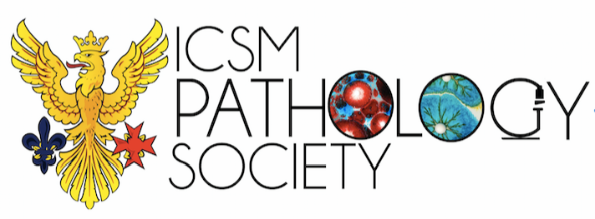

Report for the year 2016/2017

ICSM Pathology started off with a unique Freshers Fair stall – where we got candidates to guess what a certain lesion (made out of clay) was, guess the number of marbles in a box as well as sign up for free membership in order to participate. The winning candidates won tickets to Escape Room – an opportunity to bond with fellow members of the group. This was very popular and we gathered 86 members during the event (huge step up from the previous year of 44 members).

For the rest of the year, the focus was on delivering high quality pathology tutorials to prepare our students for the Yr5 Pathology exam which is known to be quite daunting for most students. The tutorials covered topics on Chemical Pathology, Microbiology, Histopathology, Immunology, Haematology and were delivered weekly during the period of November- January. We also arranged a Careers evening in February where students interested in Pathology could come and have any questions answered. We tried to arrange a few more talks but had cancellations last minute. We finished the year with an AGM in April to elect new committee members.

Our aim was to increase the visibility of the society as well as deliver high quality tutorials to our students. We also wanted to start organising talks that can allow students to gain further insight into the extensive field of Pathology.

TO evaluate our success, we printed off feedback forms for the various tutorials we conducted. We received excellent feedback with regards to content of tutorial, delivery and structure. Students also appreciated the fact that the tutorials started early in November as opposed to in January (in previous years), which kick-started their revision early.
We felt that Freshers Fair allowed us to increase our visibility as is reflected by the increase in the number of members compared to the previous year.

With regards to talks oriented towards a career in Pathology, we were unable to deliver this during the year however, we discussed this vision to the upcoming committee to aim to deliver this in 2018. This idea was realised and on 15th May 2018 – ICSM Pathology arranged a talk with Professor Rob Goldin (Honorary President of ICSM Pathology Society and Consultant HistoPathologist) as well as Professor Jane Apperly (Consultant Haematologist). Professor Goldin spoke about his expansive career and the countless opportunities available to us as students to get a head-start in the field. Professor Apperly provided insight into her expertise in the field of Chronic Myeloid Leukemia, Bone Marrow transplants and the 1000 Genome Project. This was a great success and we plan on continuing this in the years to come!

With regards to finances:

Escape rooms | 95GBP
Roller banner, leaflets | 56GBP
Food for tutorials | 35GBP

